24CSI024-DATA STRUCTURES AND ALGORITHMS
UNIT 1-INTRODUCTION TO DATA STRUCTURES AND ALGORITHMS
Arrays and Array-Based Techniques (Two-Pointer, Sliding Window, Prefix Sums) LAB WORKBOOK-16.07.2026

CATEGORY: EASY

Question 1: Merging Two Sensor Logs (Two-Pointer)
Two weather stations, A and B, each recorded temperature readings independently and stored them in non-decreasing sorted order. Divya needs to merge both logs into a single sorted array for her analysis dashboard — without using any built-in sort function, and in O(N + M) time.
She uses the two-pointer merge technique:
- Initialize a pointer i at index 0 of array A and a pointer j at index 0 of array B.
- Compare A[i] and B[j]. Copy the smaller value into the output array and advance that pointer.
- Repeat until one array is exhausted.
- Copy any remaining elements of the other array directly into the output.
  - The first line of input consists of two space-separated integers N and M — the sizes of arrays A and B.
  - The second line consists of N space-separated integers (array A, sorted).
  - The third line consists of M space-separated integers (array B, sorted).
  - Print a single line of N + M space-separated integers representing the merged sorted array.
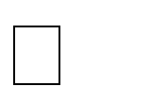

  - 1 N, M 10000



  - 104 arr[i] 104

Input 1: Input 2:

10 | 2 2  0 0  -1 4
Output: Output:

5 8 9 10 | -1 0 0 4

AIM:

To merge two sorted arrays into a single sorted array using the Two-Pointer technique in O(N + M) time.

PSEUDO CODE:

set i = 0, j = 0, k = 0

while i < N and j < M

if A[i] <= B[j]

C[k] = A[i]

i = i + 1

else

C[k] = B[j]

j = j + 1

endif

k = k + 1

while i < N

C[k] = A[i]

i = i + 1

k = k + 1

while j < M

C[k] = B[j]

j = j + 1

k = k + 1

CODE:

#include<stdio.h>

int main()

{

int n,m;

scanf("%d%d",&n,&m);

int k=n+m;

int arr[n],brr[m],crr[k];

for(int i=0;i<n;i++)

{

scanf("%d",&arr[i]);

}

for(int j=0;j<m;j++)

{

scanf("%d",&brr[j]);

}

int i=0,j=0;

k=0;

while(i<n || j<m)

{

if(arr[i]<=brr[j])

{

crr[k]=arr[i];

i++;

}

else

{

crr[k]=brr[j];

j++;

}

k++;

}

while(j<m)

{

crr[k]=brr[j];

j++;

k++;

}

while(i<n)

{

crr[k]=arr[i];

i++;

k++;

}

for (int i = 0; i < n+m; i++)

{

printf("%d ", crr[i]);

}

return 0;

OUTPUT:

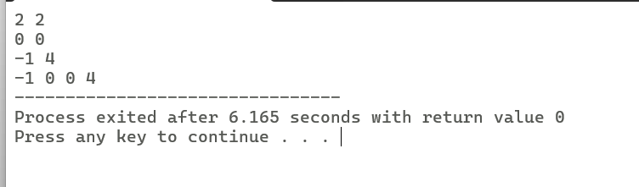

RESULT:

The two sorted array was successfully merged into one array using two pointer technique

}

Question 2: Locating the First Below-Threshold Reading (Linear Search)
Farhan monitors battery voltage readings from a fleet of IoT sensors, logged in

the order they were received (not sorted). He needs to find the position of the first reading that drops below a safe voltage threshold T, so maintenance can pinpoint when the fault began.
  - The first line of input consists of two space-separated integers N and T.
  - The second line consists of N space-separated integers representing the voltage readings, in the order recorded.

  - Print a single integer: the 0-indexed position of the first reading strictly less than T. If no such reading exists, print -1.


  - 1 N 10000



  - 103 arr[i], T 103

Input 1: Input 2:

6 5  9 7 6 4 8 3 | 4 0  1 2 3 4
Output: Output:

3 | -1

AIM:

To find the first element that is less than the given threshold using the Linear Search technique

PSEUDO CODE:

Read N andT

if current element < T

Print the index

stop

endif

endfor

Print -1

CODE:

#include<stdio.h>

int main()

{

int n,t;

scanf("%d%d",&n,&t);

int arr[n];

for(int i=0;i<n;i++)

{

scanf("%d",&arr[i]);

}

for(int i=0;i<n;i++)

{

if(arr[i]<t)

{

printf("%d",i);

return 0;

}

}

printf("-1");

return 0;

}

OUTPUT:

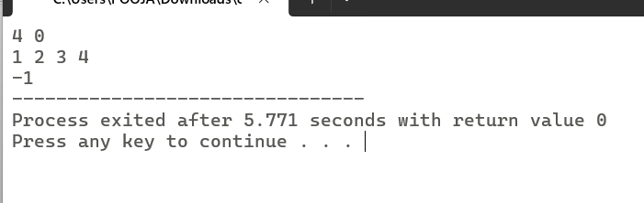

RESULT:

The first voltage reading below the given threshold was successfully located using the Linear Search technique. If no such reading exists, the program outputs -1.

CATEGORY: MEDIUM

Question 3: Maximum Rainwater Between Towers (Two-Pointer)
A telecom company has N transmission towers of varying heights standing in a row. During heavy rain, water can collect in the “well” formed between two towers, bounded by the shorter of the two. Meera wants to find the two towers that can trap the maximum volume of water between them, so she can plan drainage.
She solves it in O(N) using two pointers instead of checking every pair:
- Initialize left = 0 and right = N - 1, and maxWater = 0.
- Compute the water trapped between left and right: min(height[left], height[right]) * (right - left). Update maxWater if this is larger.
- Move the pointer at the shorter tower inward — it can never form a better pair with anything closer than the taller side already offers.
- Repeat until left meets right.
  - The first line of input consists of an integer N — the number of towers.
  - The second line consists of N space-separated non-negative integers representing tower heights.
  - Print a single integer representing the maximum water that can be trapped, in the

format: Max Water: X.


  - 2 N 10000


  - 0 height[i] 104

Input 1: Input 2:

2 5 4 8 3 7 | 4  1 1 1 1
Output: Output:

Max Water: 49 | Max Water: 3

AIM:

To find the maximum amount of water that can be trapped between two towers using the Two-Pointer technique.

PSEUDO CODE:

left = 0

right = N - 1

maxWater = 0

while left < right

width = right - left

height = minimum(height[left], height[right])

water = width × height

if water > maxWater

maxWater = water

endif

if height[left] < height[right]

left = left + 1

else

right = right - 1

CODE:

#include<stdio.h>

int main()

{

int n;

scanf("%d",&n);

int arr[n];

for(int i=0;i<n;i++)

{

scanf("%d",&arr[i]);

}

int l=0;

int r=n-1;

int m=0;

while(l<r)

{

int h;

if(arr[l]<arr[r])

{

h=arr[l];

}

else

{

h=arr[r];

}

int w=r-l;

int wt=w*h;

if(wt>m)

{

m=wt;

}

if(arr[l]<arr[r])

{

l++;

}

else

{

r--;

}

}

printf("Max Water: %d",m);

return 0;

}

OUTPUT:

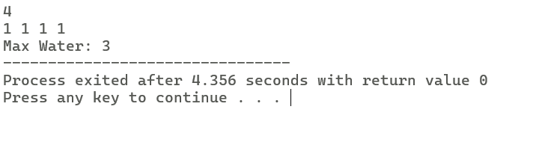

RESULT:

The maximum amount of water that can be trapped between two towers was successfully found using the Two-Pointer technique in O(N) time.

Question 4: Finding the Insertion Point for a New Calibration Value (Binary Search)
A lab keeps a sorted array of calibration reference values. Whenever a new value arrives, Ibrahim needs to find the exact index where it should be inserted to keep the array sorted — without scanning the whole array.
He uses a binary search variant that finds the first index whose value is greater than or equal to the new value:
- Initialize low = 0, high = N.
- While low < high: compute mid = low + (high - low) / 2.
- If arr[mid] < target, set low = mid + 1. Otherwise, set high = mid.
- When the loop ends, low is the correct insertion index.
  - The first line of input consists of two space-separated integers N and target.
  - The second line consists of N space-separated integers in non-decreasing order.
  - Print a single integer: the index at which target should be inserted, in the format: Insert At: X.


  - 1 N 10000



  - 104 arr[i], target 104

Input 1: Input 2:

6 | 29 |  |  |  |  | 4 | 5
10 | 20 | 30 | 40 | 50 | 60 | 1 | 2 | 3 | 4
Output: Output:

Insert At: 2 | Insert At: 4

AIM:

To find the correct insertion index of a target element in a sorted array using the Binary Search technique.

PSEUDO CODE:

low = 0

high = n

while low < high

mid = (low + high) / 2

if arr[mid] < target

low = mid + 1

else

high = mid

endif

endwhile

CODE:

#include<stdio.h>

int main()

{

int n,t;

scanf("%d%d",&n,&t);

int arr[n];

for(int i=0;i<n;i++)

{

scanf("%d",&arr[i]);

}

int l=0;

int h=n;

while(l<h)

{

int mid=l+(h-l)/2;

if(arr[mid]<t)

{

l=mid+1;

}

else

{

h=mid;

}

}

printf("Insert At:%d",l);

return 0;

}

OUTPUT:

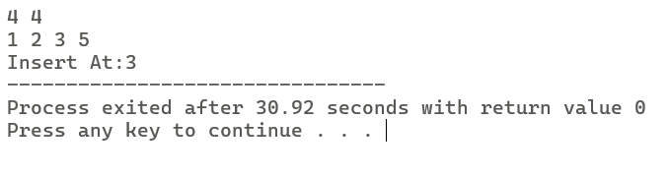

RESULT:

The correct insertion index of the target element was successfully found using the Binary Search technique in O(log N) time.

CATEGORY: HARD

Question 5: Locating a Packet in a Rotated Log Buffer (Modified Binary Search)
A circular network buffer stores log entries sorted by timestamp, but because it wraps around, the array as read out is a rotated sorted array (e.g., the oldest entries appear after the newest due to the wraparound point). Sana needs to locate a specific timestamp T in O(log N) time — a plain binary search won’t work directly since the array isn’t fully sorted end-to-end.
She adapts binary search to handle the rotation:
- Initialize low = 0, high = N - 1.
- Compute mid. If arr[mid] == target, return mid.
- Determine which half (low to mid, or mid to high) is properly sorted by comparing arr[low] and arr[mid].
- Check if target lies within the value range of the sorted half. If it does, recurse/iterate into that half; otherwise, search the other half.
- Repeat until found or the range is empty.
  - The first line of input consists of two space-separated integers N and target.

  - The second line consists of N space-separated distinct integers representing the rotated sorted array.
  - Print a single integer: the 0-indexed position of target in the array, in the format: Found At: X. If not present, print Found At: -1.


  - 1 N 10000



  - 105 arr[i], target 105
  - The array is a sorted array rotated at some unknown pivot; all elements are distinct.

Input 1: Input 2:

7 0  4 5 6 7 0 1 2 | 5 3  4 5 6 7 8
Output: Output:

Found At: 4 | Found At: -1

AIM:

To find the position of a target element in a rotated sorted array using the Modified Binary Search technique.

PSEUDO CODE:

low = 0

high = n - 1

while low <= high

mid = (low + high) / 2

if arr[mid] == target

print mid

stop

if arr[low] <= arr[mid]

if target >= arr[low] and target < arr[mid]

high = mid - 1

else

low = mid + 1

else

if target > arr[mid] and target <= arr[high]

low = mid + 1

else

high = mid - 1

endif

print -1

CODE:

#include<stdio.h>

int main()

{

int n,t;

scanf("%d%d",&n,&t);

int arr[n];

for(int i=0;i<n;i++)

{

scanf("%d",&arr[i]);

}

int l=0;

int h=n-1;

while(l<=h)

{

int mid=l+(h-l)/2;

if(arr[mid]==t)

{

printf("Found At:%d",mid);

}

if(arr[l] <= arr[mid])

{

if(t >= arr[l] && t < arr[mid])

{

h = mid - 1;

}

else

{

l = mid + 1;

}

}

else

{

if(t > arr[mid] && t<= arr[h])

{

l = mid + 1;

}

else

{

h = mid - 1;

}

}

}

printf("Found At: -1");

return 0;

}

OUTPUT:

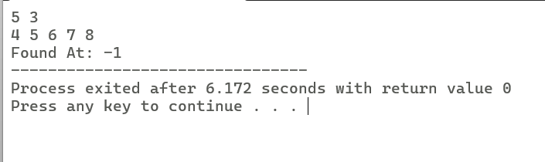

RESULT:

The target element was successfully searched in the rotated sorted array using the Modified Binary Search technique with a time complexity of O(log N).

VIVA QUESTIONS:

- “In binary search, why must the array be sorted before we can safely discard half the search space at each step? What breaks if it isn’t?”
Binary search works only on a sorted array because it decides whether to search the left half or the right half based on the middle element. If the array is not sorted, we cannot know which half contains the target, so we may discard the wrong half and miss the element
- “Contrast the worst-case and best-case time complexity of linear search. Under what real-world circumstance would linear search actually outperform binary search on the same data?”
Best case: O(1) when the element is found at the first position.
Worst case: O(N) when the element is at the last position or not present.
Linear search can be faster for small arrays or when the required element is near the beginning because it finds the element immediately without dividing the array repeatedly.
- “In the rotated sorted array search problem, why can’t we simply check if arr[mid] < target the way we would in a standard binary search? What extra information do we need at each step?”
In a rotated sorted array, the entire array is not sorted. So comparing only arr[mid] with the target is not enough. We first need to find which half is sorted, then check whether the target lies in that sorted half before deciding where to continue the search.

- “The two-pointer merge technique for two sorted arrays runs in O(N+M) time. Why would sorting the concatenation of both arrays from scratch be a worse approach, even though both are technically valid?”
Since both arrays are already sorted, we can merge them by comparing elements one by one in O(N + M) time. If we first combine them and sort again, it takes about O((N + M) log(N + M)), which is slower and does unnecessary work.
- “In the ‘maximum rainwater between towers’ problem, why is it always safe to move the pointer at the shorter tower inward, and never the taller one?”
The amount of water depends on the shorter tower. Moving the taller tower cannot increase the water because the shorter tower still limits the height. By moving the shorter tower, we may find a taller one and get a larger area.

- “low + (high - low) / 2 is preferred over (low + high) / 2 for computing the midpoint in binary search. What specific failure does this guard against, and under what conditions would that failure actually occur in C?”
Using (low + high) / 2 can cause integer overflow when low and high are very large. low + (high - low) / 2 avoids this overflow and gives the correct midpoint. This mainly happens when working with very large arrays in C.
- “If you were asked to implement binary search recursively instead of iteratively in C, what trade-off would you be making in terms of memory, and why does this matter for embedded systems with limited stack size?”
For small arrays, linear search checks elements one by one in order, which is simple and cache-friendly. Binary search jumps to different positions, which may reduce cache efficiency. Because of this, linear search can sometimes run faster on small arrays even though its time complexity is worse
.
- “How would you modify binary search to find the last occurrence of a repeated value in a sorted array, rather than just any occurrence?”
When the target is found, I would store its index and continue searching the right half of the array. This ensures I find the last occurrence instead of stopping at the first one.
- “Explain why the two-pointer technique for merging arrays cannot be applied directly if one of the arrays is unsorted. What would need to change?”
The merge technique assumes that both arrays are already sorted. If one array is unsorted, we cannot decide which element is smaller by looking only at the current pointers. We must first sort the unsorted array before using the two-pointer merge technique.

- “In terms of cache behavior, why might linear search on a small array sometimes run faster in practice than binary search, despite having worse asymptotic complexity?”
For small arrays, linear search checks elements one by one in order, which is simple and cache-friendly. Binary search jumps to different positions, which may reduce cache efficiency. Because of this, linear search can sometimes run faster on small arrays even though its time complexity is worse.

